NEWSLETTER August 2022

Research Committee

**Updates**

**Arc PGC Research Awards 2022**  
  
**Know a fellow HDR candidate, supervisor**, or professional staff who has done something above and beyond to improve the HDR experience at UNSW? Nominate them for the Arc PGC Research Awards!  
   
Nominations are open via an easy, one-question nomination form at <https://unsw.to/PGCResearchAward2022> (Closes 8 August 2022)  
   
The annual awards ceremony will be held in November, celebrating the contributions of outstanding HDR candidates, supervisors, and professional staff. All HDR candidates, supervisors and staff are eligible for nomination, and you are welcome to nominate more than one individual!

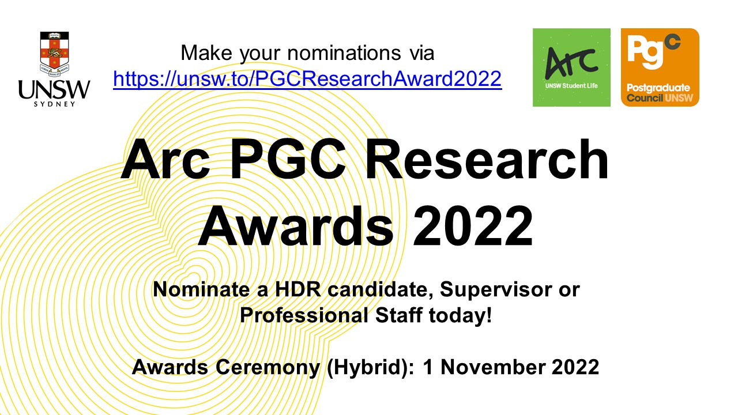

**Events**

**External events**

Statscentral Recordings

<https://www.analytical.unsw.edu.au/facilities/stats-central/monthly-seminars>

UNSW R Coders Session Recordings

<https://unsw-coders.netlify.app/workshops/>

Workshop Recordings on Communication by Prof. Michael Kent, UNSW

<http://www.mlkent.com/SydneyLectures.html>

Coursework Committee

**Updates**

Collaboration with International office, Career Development Workshop - See below (International office)

A series of events were held across campus throughout Stress-less Week, Monday 18th to Thursday 21st July.

The Coursework office hosted a Coffee and Chat event at the Postgraduate Lounge on Tuesday 19th July, welcoming postgrads in a casual and relaxed environment. Postgrads were able to kick back and relax, meeting new friends while sharing stories and de-stressing.

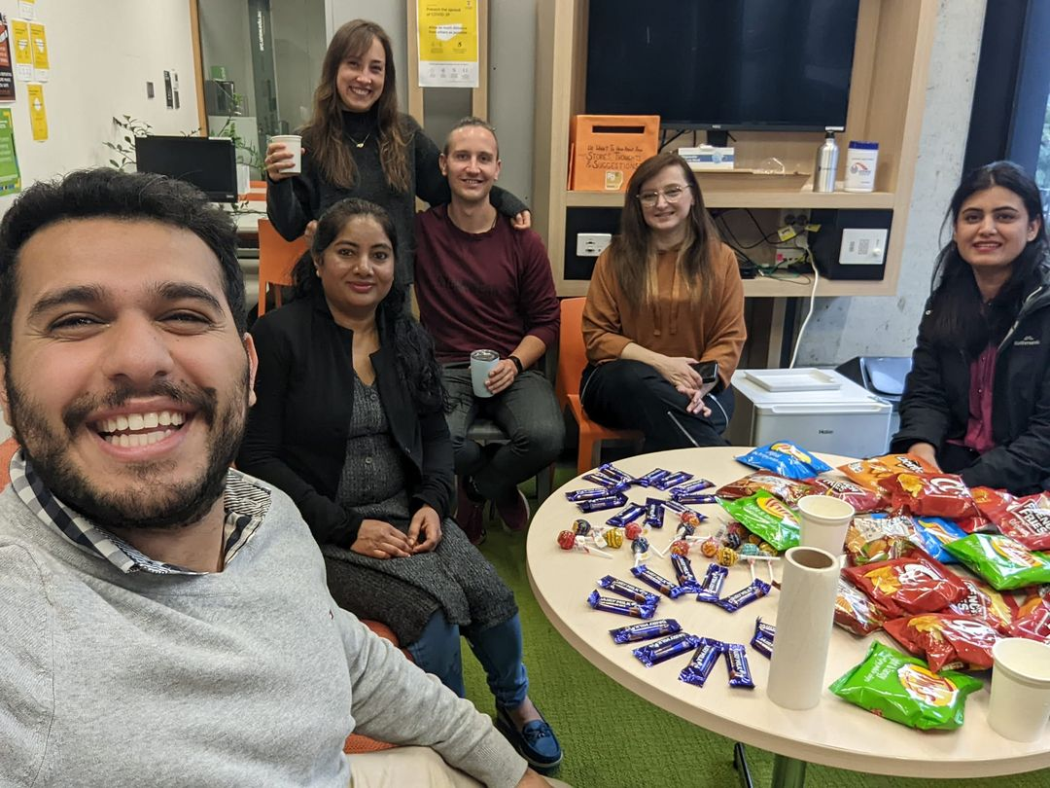

**Events**

**Cockatoo Island Trip**

Interested in visiting Cockatoo Island and learning about the Island’s Convict Precinct for a discounted price of $5 per student (rrp $16)? Want to meet new postgraduate friends? Well you won’t want to miss out on our Cockatoo Island Trip!

Date: TBC (Will be on Facebook in a week)

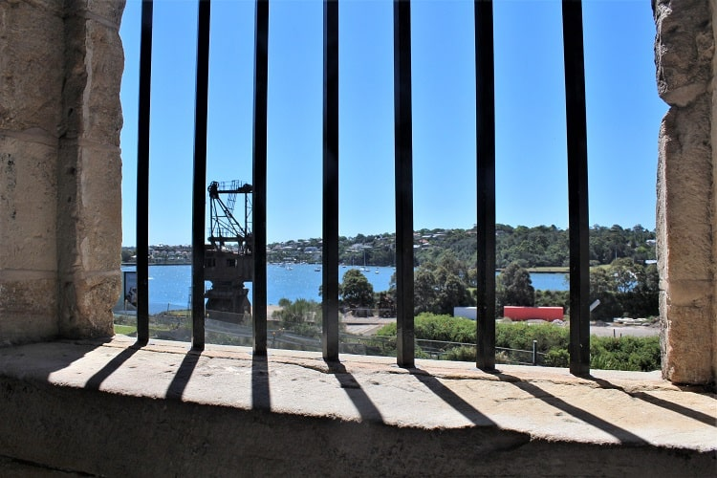

**External events**

International Committee

**Updates**

The International and Coursework offices of the Postgraduate Council, in partnership with Hong Kong Australia Business Association, put together a career development workshop specially designed for the international postgraduate students on 4th of July. Special thanks to our two keynote speakers Kaley and Steven who brought us wonderful presentations and workshops.

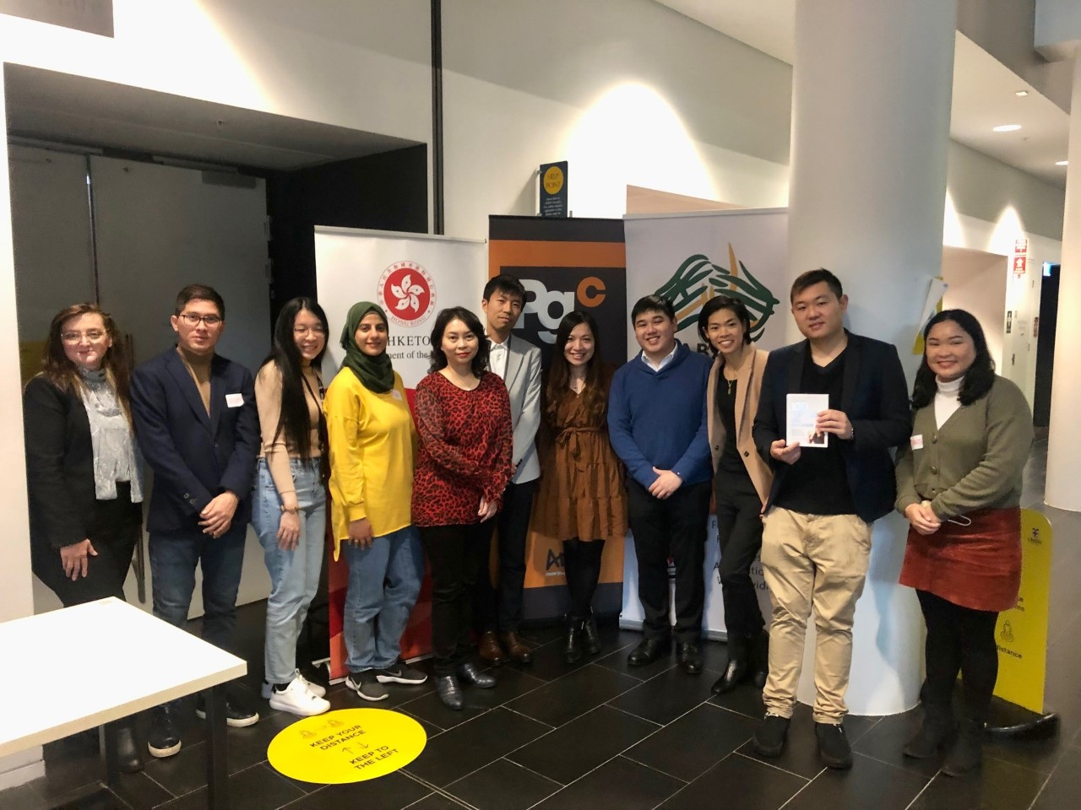

Equity Committee

**Updates**

**Events**

**External events**